

**CS 319 Object Oriented Software Engineering**

**Iteration 2 - Final Report**

**Endless Dungeon**

**Group 2B**

Can Özgürel

Alperen Kaya

Batuhan Erarslan

Alemdar Salmoor

**1. Implementation Process** **3**

**2. System Requirements** **4**

**3. Changes** **4**

**4. User’s Manual** **5**

4.1 Main Menu 5

4.2 Game Screenshot 6

4.3 Settings 7

4.4 How to Play 7

4.5 Credits 8

# 

# 1. Implementation Process

We started the implementation process by dividing the tasks between group members. We have decided that it was appropriate to divide the project into three parts for this iteration. One member was responsible for game objects, one for user interface and two of us were to implement game manager which handled the operations necessary for playing the game. Around this time one of our members had to leave the city due to an unfortunate situation regarding their family, therefore our workload increased somehow but it was not too damaging to the process.

Even though we divided the tasks we still helped each other in the process and made mutual changes in our code and design. It was not awfully difficult to implement the game at this bare-bones level with the fundamental parts. Although during the implementation process we have realized some problems in our design logic and tried to fix them as possible. Via this process we have learned to work better as a group and learn from our mistakes.

Unfortunately, we were not able to finish all of the firstly planned features such as load and save procedure. The reason behind it, we decided to change our architectural style from MVC to Three Layer Architectural Style. In addition to that we also decided to use Swing instead of Javafx. Therefore, we lost a lot of time by doing these changes. However, there were more functionalities that we were able to implement.

To sum up, we have some small missing features, however, we completed the main dynamics of our game. We follow the Object Oriented Programming principles and we learned how to work as a team.

# 2. System Requirements

Java Virtual Machine and Java SDK must be downloaded to computer. These two is enough to run the game.

# 3. Changes

We discovered some problems with our design and we made the according changes in the implementation. We have added, removed and relocated a few methods mostly in the object classes. We also have taken out some of the designed functionalities in order to be able to implement a working software in the limited time we had, especially with all of us having other exams and deadlines.

As mentioned above, we changed our architectural style from MVC to Three Layer Architectural Style because we realize that we need more communication between our classes.

For practicing Object Oriented Programming design patterns, we improve our implementation by using more design patterns such as Singleton Design Pattern and Facade Pattern. We design GamaManager and ObjectHandler classes by the fundamentals of Singleton Pattern. Additionally, we implement GamePanel, GamaManager and ObjectHandler classes by Facade Pattern.

Another change is that we use Swing instead of Javafx. The reason of this, we had to improve our skills on Javafx to complete the project but we waste some time by changing design patterns and classes. Therefore, instead of improving our JavaFx skills, we decided to go with Swing and gain some time.

We also passed on the idea of creating different difficulty levels since, enemies already get stronger as the waves progress. And since it is a turn based game, attributes that would be affected by optional game difficulty changes and difficulty levels that change due to the wave number would be the same.

# 4. User’s Manual

## 4.1 Main Menu

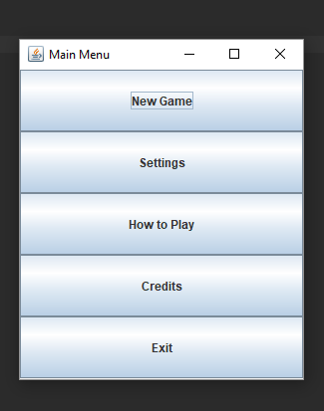

After running the game, Main Menu screens shows up. User can start the game by choosing New Game button. By the help of the Settings button, user can open the settings screen where they can change game settings. How to Play button helps user to understand dynamics of our game. Credits button opens the screen which shows the credits of the game. Finally, by clicking Exit button user can quit from the game.

## 4.2 Game Screenshot

## 

This screenshot illustrates what Endless Dungeon looks like.

## 4.3 Settings

This is the Settings Menu where a user can change currently played sounds, adjust the volume and mute the in game sounds altogether.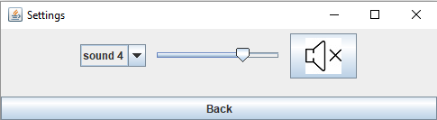

## 4.4 How to Play

## 

This is a How to Play page where you can learn about basic game mechanics and interactions

## 4.5 Credits

A credits page of the Endless Dungeon Game